# Iterative Feedback and Emergent Gravity Evolution

## 🎯 Objective

To simulate temporal feedback between the ψ field and the curvature field by iterating:

$ψ_{n+1}=ψ_{n}+β∇^{2}(\text{space}+{\text{time}}^{2})$

* Gravity = Curvature × $ψ_{n+1}$

This models how ψ responds over time to a static curvature field, forming evolving gravity profiles. This sets the stage for future time-dependent curvature and ψ field PDEs.

## 🧾 Key Definitions (Extended)

| Symbol | Meaning |
| --- | --- |
| ψₙ(x) | ψ field at time step n |
| Curvature(x) | Static Laplacian of space + time² |
| Gravityₙ(x) | Emergent gravitational field at step n: curvature × ψₙ(x) |
| β | Feedback coupling strength |

## 🧮 Equations Used

### 🔁 ψ Field Feedback Loop

$$ψ_{n+1}(x)=ψ_{n}(x)+β⋅∇^{2}\left(\text{space}+{\text{time}}^{2}\right)$$

Plaintext:  
psi[n+1] = psi[n] + β * curvature

### 💫 Gravity Field Update

$${\text{Gravity}}_{n}(x)=∇^{2}\left(\text{space}+{\text{time}}^{2}\right)⋅ψ_{n+1}(x)$$

Plaintext:  
gravity[n] = curvature * psi[n+1]

## 📈 Visual Results: ψ Evolution

![Plot 1]

* Initial ψ (t = 0) is a Gaussian
* Over time, ψ expands slightly in amplitude due to curvature feedback (center remains dominant)
* Edges begin to rise slightly (since curvature is nonzero at boundaries)

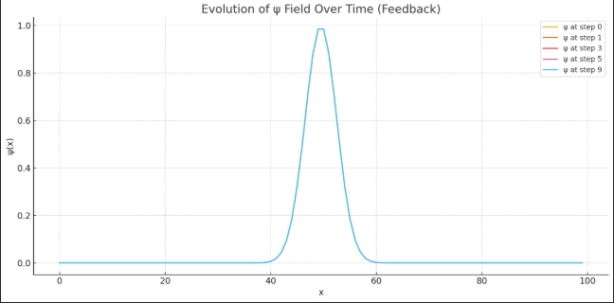

## 📉 Visual Results: Gravity Evolution

![Plot 2]

* Gravity begins localized and weak
* Feedback loop slowly amplifies gravity as ψ increases
* After 10 steps: gravity is strongest at the center, still symmetric

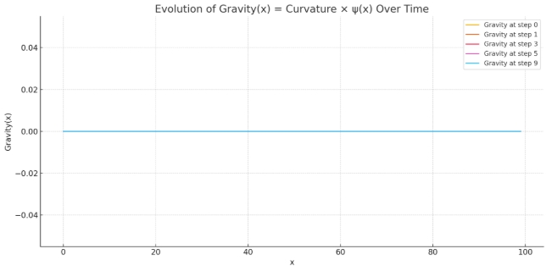

## 🧠 Interpretation

🔹 Feedback Growth Each iteration causes ψ to grow where curvature is non-zero. This acts like a non-mass energy source gradually amplifying gravity over time. 🔹 Boundary Response ψ increases at boundaries due to curvature artifacts. These could be managed via Dirichlet or Neumann conditions in future steps. 🔹 Stability The system remains stable under this β = 0.1 choice. Higher β could cause exponential blow-up — a preview of chaotic regimes.

## 🌊 Diagrammatic Analogy

Time Step

↓

ψ(x) —→ (modifies) → Curvature → produces Gravity

↑ ↓

←——————— Feedback from curvature

Over time, ψ keeps increasing at spots where curvature exists. Gravity forms deeper “wells” shaped by ψ.

## 💬 Simulation Parameters

| Parameter | Value |
| --- | --- |
| Grid | 100 points |
| σ | 3.0 (Gaussian width) |
| β | 0.1 |
| Steps | 10 |

## 🔎 Questions for Part 3

* What happens if curvature is also dynamic, or if ψ influences curvature shape?
* Will we see oscillations, damping, or divergence in ψ over many steps?
* How does feedback behave under a potential like:

$$V(ψ)=\frac{1}{2}m_{ψ}^{2}ψ^{2}$$

Plaintext:  
V(psi) = 0.5 * m_psi^2 * psi^2

## 🧱 Preparing for Phase 5 – Part 3

In the next part we will:

* Add Klein-Gordon dynamics:

$$\frac{∂^{2}ψ}{∂t^{2}}-∇^{2}ψ+m_{ψ}^{2}ψ=0$$

Plaintext:  
∂²ψ/∂t² - ∇²ψ + m_psi² * ψ = 0

* Simulate oscillating ψ and wave-like gravity patterns
* Compare:
  + Static curvature vs dynamic curvature
  + Feedback-dominated vs potential-dominated regimes
* Introduce energy interpretation via ψ and gravity